

**Stage 2**

**Nagham Thamer Al-Otaibi**

**202110560**

**Kinda Suleiman Aldardese**

**202110811**

**Maya Amjad Salsaa**

**202110124**

**URL for the form:**

[Petra.com form.](https://docs.google.com/forms/d/e/1FAIpQLSfZ_JvkfnsI-mpBNgRtk1aAQaKzJib62CO3YaZhqBOTiBt4sQ/viewform?usp=sf_link)

**Form responded:**

In today's online shopping world that succeeds in implementing fast experiences, companies that matter resonate with their customers. This study explores how male and female online shoppers of different generations discover their preferences. We collected responses from a diverse group of participants on what each gender faces. By looking at various differences such as how often they shop online, their preferred products, shipping options, preferred payment speed, and the most important features, sometimes we aim to understand what influences their shopping. We also monitored them about customer support, the importance of tracking orders in actual work, their feelings about assigned tasks, their acceptance of policies, and getting work done through the website. This research aims to provide valuable insights that can help e-commerce boards tailor their unique demand offering to both male and female shoppers.

**Q1:**

This form was supposed to be answered by 100 people, but it was answered by only 174 people, specifically 119 (68.8%) females and 54 (31.2%) males, and this indicates that females use websites to do shopping more than males. (173 responses)

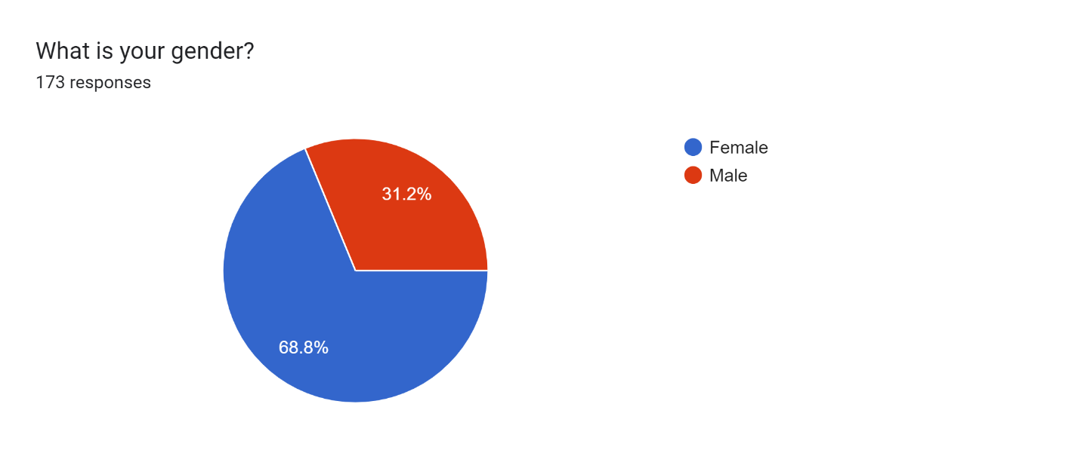

**Q2:**

**Through the model, it was found that the largest percentage of ages was for young people whose ages ranged from 18-24, and the lowest percentage was for the elderly over 54** (173 responses)

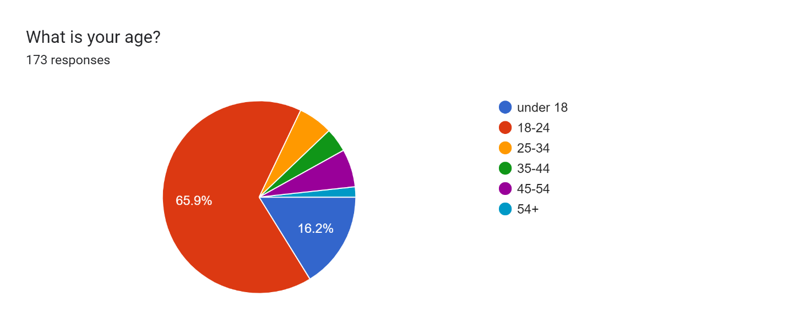

**Q3:**

**The percentage of using online shopping ranged from sometimes to rarely, and the percentage of those who did not use it was very small** (172 responses)

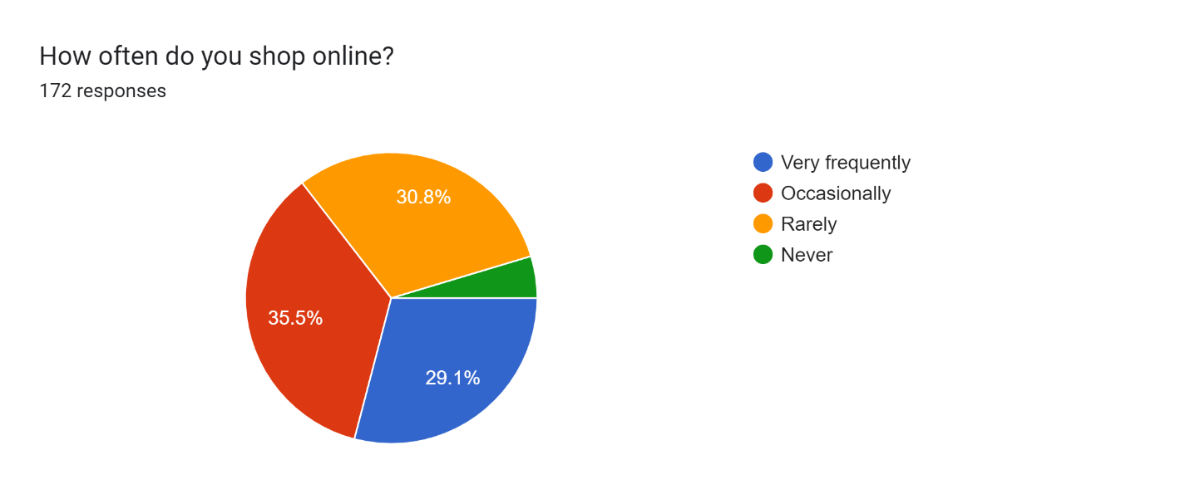

**Q4:**

**We asked about the things that are bought the most, and the result was that clothes are the most bought** (173 responses)

**Forms response chart. Question title: What types of products do you usually shop for online? (Select all that apply)
. Number of responses: 173 responses.**

**Q5:**

**Regarding the delivery method, most people prefer normal shipping, and they do not like extra freight for faster delivery** (171 responses)

**Forms response chart. Question title: Which shipping option do you prefer?
. Number of responses: 171 responses.**

**Q6:**

As for the method of payment, credit card is most preferred, and secondly upon receipt (173 responses)

**Forms response chart. Question title: Which payment methods do you prefer when making online purchases? (Select all that apply)
. Number of responses: 173 responses.**

**Q7:**

We have seen that most people like to track the shipment because they are excited and eagerly awaiting their order (172 responses)

**Forms response chart. Question title: How important is real-time tracking of your order delivery progress to you?
. Number of responses: 172 responses.**

**Q8:**

A large number of people prefer personal communication over the phone with customer service so that they feel that someone cares about the complaint and they do not need to wait for a response (171 responses)

**Forms response chart. Question title: What type of customer support do you find most helpful during online shopping?
. Number of responses: 171 responses.**

**Q9:**

Most customers like to see some recommendations to make it easier for them to search (173 responses)

**Forms response chart. Question title: How would you feel about receiving personalized recommendations based on your purchase history and preferences?
. Number of responses: 173 responses.**

**Q10:**

More than half of those who made the form prefer the exchange and return service (172 responses)

**Forms response chart. Question title: How important is a transparent and easy return/exchange policy to you?
. Number of responses: 172 responses.**

**Q11:**

The site should be easy to use, and this was the opinion of the majority, and most do care

(171 responses)

**Forms response chart. Question title: How important is an intuitive and user-friendly website navigation to you?
. Number of responses: 171 responses.**

**Q12:**

As we can see, among the features that we suggested to them, the results were similar, meaning they liked all the features (171 responses)

**Forms response chart. Question title: Which features would enhance your shopping experience? (Select all that apply)
. Number of responses: 171 responses.**

**Q13:**

We have voted that we should do a subscription service for the site, and the result was that most agree or are not interested (170 responses)

**Forms response chart. Question title: Would you be interested in a subscription service for regularly purchased items, with automatic shipments and discounts?
. Number of responses: 170 responses.**

**Q14:**

We asked them an open-ended question about what they want to be added to the site and what they would like to have in it (60 responses)

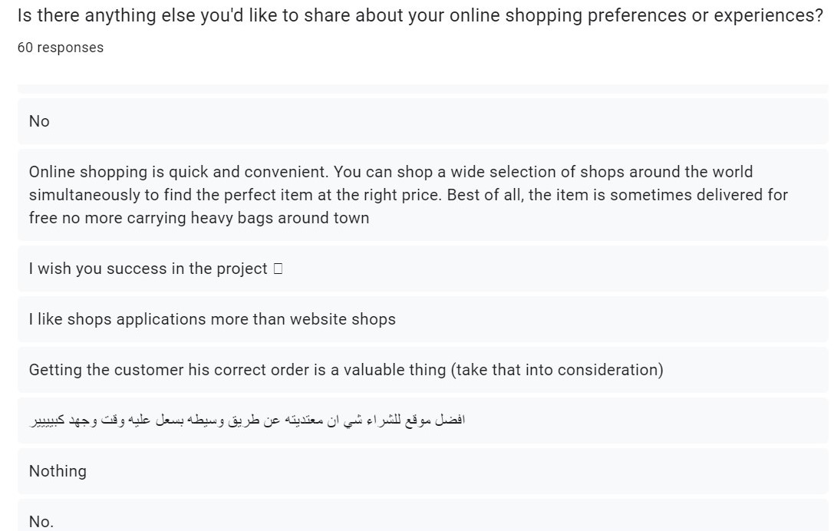

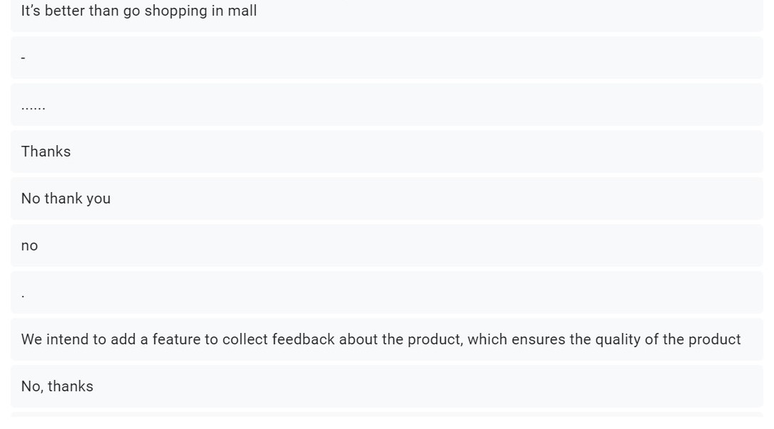

**The average:**

|  |  |
| --- | --- |
| **Question** | **Average** |
| **Q1** | **Female** 68.7%  **Male** 31.3% |
| **Q2** | **under 18** 15.9%  **18-24** 67%  **25-34** 5.5%  **35-44** 3.8%  **45-54** 6%  **54+** 1.6% |
| **Q3** | **Very frequently** 30.4%  **Occasionally** 35.4%  **Rarely** 29.8%  **Never** 4.4% |
| **Q4** | **Electronics** 34.6%  **Clothing and fashion** 75.8%  **Home and kitchen appliances** 24.7%  **Books and media** 21.4%  **Beauty and personal care** 46.2%  **Groceries** 33%  **Other** 5.2% |
| **Q5** | **Standard shipping** 50.6%  **Express shipping with higher cost** 7.8%  **Same-day delivery(if available)with higher cost** 12.8%  **In-store pickup** 5.6%  **I don't have a preference** 23.3% |
| **Q6** | **Credit/debit cards** 72%  **PayPal** 13.2%  **Apple Pay / Google Pay** 17.6%  **Bank transfer** 14.8%  **Cryptocurrencies** 4.4%  **Other** 18.8% |
| **Q7** | **not important** 9.9%  **Kinda important** 30.9%  **reasonably important** 23.8%  **very important** 35.4% |
| **Q8** | **Live chat** 29.1%  **Email support** 11.2%  **Phone support** 40.2%  **Comprehensive FAQ and self-help resources** 2.8%  **Social media support** 16.2%  **Other** 0.6% |
| **Q9** | **Very Positive** 21.4%  **Positive** 45.6%  **Neutral** 29.1%  **Negative** 3.3%  **Very Negative** 0.5% |
| **Q10** | **Very Important** 58.6%  **Important** 22.1%  **Neutral** 14.4%  **Not Important** 4.4%  **Not Applicable** 0.6% |
| **Q11** | **Very Important** 33.9%  **Important** 35%  **Neutral** 28.9%  **Not Important** 0%  **Not Applicable** 2.2% |
| **Q12** | **Personalized product recommendations** 43.9%  **Wish list and saved items** 57.2%  **Enhanced customer reviews with photos and videos** 56.7%  **Live chat customer support** 40%  **Exclusive member discounts and rewards** 41.7% |
| **Q13** | **Very interested** 21.2%  **Somewhat interested** 30.2%  **Neutral** 33%  **Not very interested** 9.5%  **Not interested at all** 6.1% |

**Conclusion:**

This study looks at the preferences of male and female online shoppers across different generations. It examines factors such as frequency, preferred products, shipping options, payment speed, and features. The research also looks at customer support, order tracking, and job satisfaction.

We discovered from the statistics that the number of females is much greater than the number of males and that their ages range from 18 to 24 years, and they prefer shopping, especially clothes, and payment by credit card, We also evaluated some of the features that we can provide on the site and we got similar percentages, and we also left the freedom to the customer to tell us some things that we can add to the site.

**Functional Requirements:**

1. The system shall allow customers to create accounts, providing necessary information such as name, contact details, and shipping address.
2. The system shall allow customers to browse through the product catalog, filter items by categories, search for specific products, and view detailed product information.
3. The system shall allow users to add items to their shopping carts, view the contents, modify quantities, and remove items.
4. The system shall guide customers through a seamless checkout process, including selecting shipping options, reviewing the order, and providing payment information.
5. The system shall allow customers to track the status of their orders, including shipping and delivery updates.
6. The system shall integrate with supplier systems to place orders for items that are out of stock or in low inventory.
7. The system shall receive real-time updates from suppliers regarding item availability, expected delivery dates, and backorders.
8. The system should include a chatbot or a customer support interface to assist customers with inquiries related to products, orders, and account management.
9. The system should facilitate the process of returning items and requesting refunds by allowing customers to initiate return requests, track the status of returns, and receive timely refunds according to the store's return policy.
10. The system shall allow customers to leave reviews and ratings for products they have purchased. The reviews and ratings should be displayed on the product pages to assist other customers in making informed decisions.

**Non-Functional Requirements:**

1. The system interface should be intuitive and easy to navigate, minimizing the learning curve for customers**.** ( **Usability** )
2. The system shall be designed to handle increased user traffic during peak periods without significant performance degradation. ( **Performance and scalability** )
3. The system should be designed to ensure that interactions have a response time of less than 5 seconds. **( Performance** )
4. The system data shall be encrypted including sensitive customer data, payment information and personal details. ( **Security** )
5. The system shall be designed to minimize the impact of hardware or software failures, ensuring uninterrupted service for customers. ( **Reliability, maintainability, availability** )
6. The system should be adaptable to multiple languages to cater to a global customer base.

( **Usability** )

1. The system should be able to support multiple currencies for pricing and transactions.

( **Usability** )

1. The system should be equipped with monitoring tools to track performance, identify bottlenecks, and optimize resource usage. ( **Availability and Performance** )
2. The system should be designed to show the date and time based on the user's local timezone, improving the global user experience. ( **Usability** **and localization** )
3. The system should be capable of displaying product prices in the local currency and allowing users to switch between different currencies. ( **Usability** **and localization** )